
Raj Kumar Goel Institute of Technology Ghaziabad
ISO 9001:2015 Certified
5th KM. STONE, DELHI-MEERUT ROAD, GHAZIABAD (U.P)-201003
Department of Computer Science & Engineering

Project Title Submission for Approval

- Course : Bachelor of Technology
- Semester : VIIth
- Branch : Computer Science & Engineering
- Project Title : KeyGuardian
- Area of Technology : Cyber-Security
- Details of Students (Max 4 Students in a batch):
S. No. | Univ. Roll No. | Name | Section | Mobile Number
1 | 2000330100149 | Pankaj Dhar Dubey | B | 6388871667
2 | 2000330100232 | Surya Pratap Singh Chauhan | D

- Project Supervisor:

( ……………. )
--------------------------------------------------------------------------------------------
OFFICE USE

Project Group No.: G-56 Approved Not Approved

Member 1 Member 2

KeyGuardian

KeyGuardian – A Comprehensive Cybersecurity Solution

Problem Statement

In the current landscape of digital protection, data security has emerged as a critical concern. The KeyGuardian project addresses this imperative need by delving into the dynamic field of cybersecurity, offering a cutting-edge approach to fortify digital identities through advanced data management. The project focuses on ensuring the confidentiality and integrity of user credentials in the face of evolving cyber threats.

Why is the particular topic chosen?

The inspiration for KeyGuardian arose during participation in a Capture the Flag Event organized by KPMG. The need to navigate through multiple tools for hash identification, decryption attempts, and other security measures led to the realization that a unified platform could streamline these processes. Thus, KeyGuardian was conceptualized as a centralized solution for cybersecurity enthusiasts and professionals.

Objective and scope of the project

The primary objective of KeyGuardian is to establish a secure and centralized platform catering to cybersecurity needs. The project facilitates functions such as encryption, decryption, hash identification, and force-decryption attempts using wordlists. With a vision to integrate multiple tools into a single accessible interface, KeyGuardian aims to simplify and enhance the user experience in the realm of cybersecurity.
Moreover, KeyGuardian is poised to offer comprehensive assistance in Competitive Coding and Problem-solving through the integration of AI and In-Built Dictionaries in upcoming releases. This pioneering initiative, referred to as "The Sixth Sense," will initially support languages such as C++ 17, Java, and Python 3. Subsequently, an expanded array of languages, including Go, Rust, and more, will be incorporated.

Methodology
Diagram:

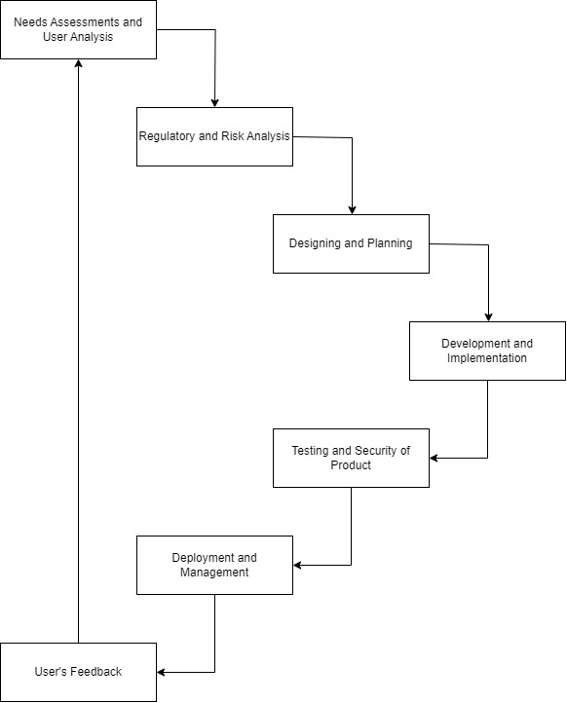

Fig 1.0 Project Model

Hardware & Software to be used

Hardware Components:

- Web Servers: A dedicated server or cloud-based server (e.g., AWS, Azure, or Google Cloud) to host the KeyGuardian application. The server should have sufficient computing resources to handle cryptographic operations efficiently.

Software Components:

- C++ Cryptographic Libraries: Utilize well-established C++ cryptographic libraries to implement advanced encryption and decryption algorithms. Libraries like OpenSSL or Crypto++ can be integrated into the project to ensure robust security measures.

- C++ Programming Language Compiler: C++ serves as the primary programming language for the development of the KeyGuardian project. Its efficiency and low-level capabilities are well-suited for cryptographic operations. The system must have a support for MingW GNU.

- Network Security Libraries: Implement network security protocols using C++ libraries to ensure secure communication between different components of the system. This may involve libraries that handle secure socket connections and data transmission.

- Database (Optional): If your project involves storing encrypted data, consider integrating a database system. Ensure that the database system is compatible with C++ and supports secure storage mechanisms.

- Integrated Development Environment (IDE): Use a C++ IDE such as Visual Studio Code, Sublime, Atom, or CLion for coding, debugging, and testing cryptographic algorithms.

- Version Control System: Implement a version control system (e.g., Git) to manage and track changes in the source code. This enhances collaboration and provides a structured approach to software development.

- Documentation Tools: Use documentation tools to maintain clear and comprehensive documentation for the project. This may include tools like Doxygen for generating code documentation.

- Build System: Implement a build system (e.g., CMake) to automate the build process of the project. This ensures consistency across different development environments and simplifies the compilation and linking of C++ code.

By incorporating these hardware and software components tailored to cryptographic algorithms and C++ libraries, the KeyGuardian project can deliver a secure and efficient solution for encryption and decryption processes.

Testing Technologies

KeyGuardian relies on C++ as the primary programming language for its implementation, leveraging the powerful capabilities of this language for robust and efficient code. The cryptographic operations are executed using Crypto++, a trusted and widely-used C++ library for cryptography. These technologies form the backbone of KeyGuardian, ensuring a high level of security in data management.
Furthermore, we plan to launch a beta version tailored for a select group of security professionals and college students, providing them with an opportunity to participate in a comprehensive trial.

Future Scope

The future scope of KeyGuardian in the rapidly advancing IT industry is exceptionally promising, given the escalating demand for tools that streamline and automate cybersecurity processes. As the IT landscape continues to expand, businesses and organizations are likely to face increasingly complex challenges in managing and securing their digital assets. KeyGuardian, with its focus on encryption and decryption automation, is poised to be a critical player in addressing these challenges. The rising volume and sophistication of cyber threats necessitate efficient and intelligent solutions that can adapt to evolving security landscapes. KeyGuardian's automation capabilities not only enhance operational efficiency but also offer a proactive defense against emerging threats. Its integration into the fabric of IT infrastructures holds the potential to significantly reduce response times, mitigate risks, and ensure a proactive stance in safeguarding sensitive data. In an era where cyber threats are dynamic and relentless, KeyGuardian stands as a beacon for the future, providing a scalable and automated approach to fortify digital defenses in the evolving IT ecosystem.

What contribution would the project make?

KeyGuardian's contribution lies in its role as a comprehensive solution to the pressing challenges of password security. By integrating encryption, proactive security features, and password management tools, the project provides users with a reliable means to safeguard their digital identities. In the face of evolving cyber threats, KeyGuardian stands as a user-centric protector, ensuring robust digital security.

In conclusion, KeyGuardian represents a significant venture into the field of cybersecurity, addressing the complexities of data protection with a comprehensive and user-friendly approach. As a testament to its innovative features, the utilization of C++ and Crypto++ technologies, and adaptable architecture, KeyGuardian stands as a formidable tool in the ongoing battle for digital security.

References

[1] Crypto++® Library 8.9 Retrieved from https://www.cryptopp.com/

[2] OpenSSL® Library 3.2 Retrieved from https://www.openssl.org/

[3] C++ 17® Standard Template Library Retrieved from https://cplusplus.com/reference/

